SIT225 Task 4P Jordan Elkin

Protocol Execution and Data Acquisition

This experiment aimed to investigate whether a low-cost and privacy-preserving sensor array could distinguish between three bathroom states: vacant, occupied without shower activity, and occupied with shower activity. The sensor system consisted of the DHT11 temperature and relative humidity sensor, PIR motion sensor, and photoresistor connected to an Arduino Nano 33 IoT as previously designed in Task 3P.

The data was collected continuously for approximately 30 minutes, with the final processed dataset containing 361 observations from the sensor array. This collection period was divided into six equal five-minute sessions so that there were multiple examples of each bathroom state. Each session was assigned a unique identifier so that readings belonging to the same bathroom-use event remained together during the decision tree classifier training and testing phases. Ventilation state was also recorded during the experiment because it had previously been identified as a factor that could influence temperature and relative humidity independently of bathroom occupancy.

Data Collection Execution

Data collection commenced at 14:07:50 on 26 September 2026 and concluded at 14:37:52, producing approximately 30 minutes of continuous sensor data. Sensor observations were recorded at approximately five-second intervals and written to a raw CSV file during collection.

Deviations

During protocol execution, several minor deviations from the revised design occurred. Shower start and finish times were not recorded separately; instead, the complete five-minute shower sessions were treated as the shower period. Data collection was also conducted using six controlled five-minute sessions rather than naturally occurring bathroom-use events. This resulted in only two independent sessions for each bathroom state, limiting the amount of data available for session-based classifier training and testing. Additionally, the two shower sessions were conducted under different ventilation conditions, with ventilation enabled during one session and disabled during the other. Environmental carry-over was also observed, as relative humidity remained elevated following shower activity and affected the baseline conditions of subsequent sessions. These deviations were retained in the analysis and considered when interpreting the results. The main reason for the deviation was due to time constraints and competing priorities.

Hardware Setup
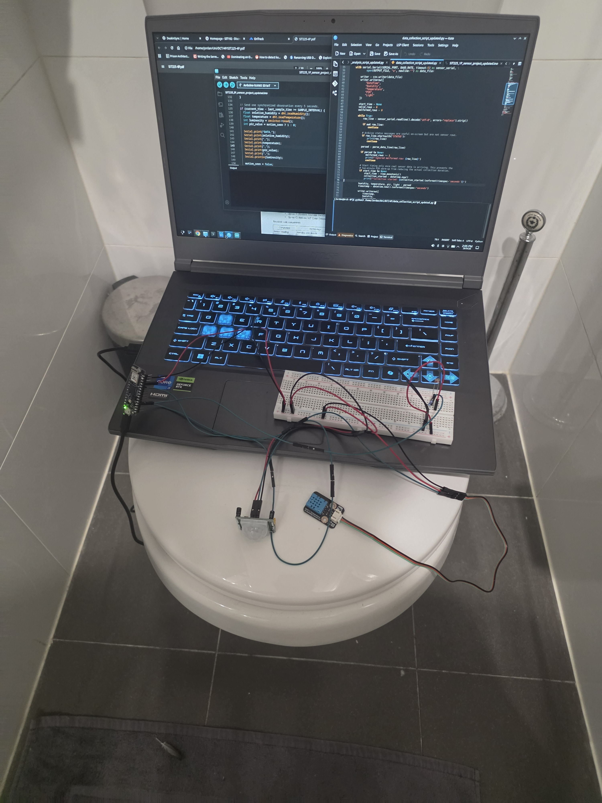

Data Quality Reporting
The raw sensor CSV was loaded into Pandas and checked for missing values, duplicate observations and readings outside the defined sensor ranges. Timestamps and sensor measurements were converted to appropriate data types before the session log was used to assign ground-truth bathroom states. Temporal features including humidity change, humidity rate of change, recent PIR activity and light change were then calculated, and the resulting dataset was exported as the processed CSV used for analysis.
Raw rows: 361
Duplicate rows removed: 0
Rows outside validation ranges removed: 0
Final valid rows: 361
Missing values before cleaning:
DateTime 0
Humidity 0
Temperature 0
PIR 0
Light 0

Statistical Analysis and Visualisations
Descriptive Statistics
 | Humidity | Temperature | PIR | Light
Count | 361.000 | 361.000 | 361.000 | 361.000
Mean | 68.067 | 24.920 | 0.413 | 574.680
Standard deviation | 3.300 | 0.249 | 0.493 | 357.113
Min | 62.900 | 24.600 | 0.000 | 50.000
25% | 65.2000 | 24.700 | 0.000 | 99.000
50% | 66.600 | 24.900 | 0.000 | 825.000
75% | 70.800 | 25.100 | 1.000 | 865.000
95% | 73.900 | 25.400 | 1.000 | 890.000
Max | 75.900 | 25.500 | 1.000 | 935.000

Correlation Matrix

 | Humidity | Temperature | PIR | Light
Humidity | 1.000 | 0.938 | -0.034 | 0.276
Temperature | 0.937 | 1.000 | -0.045 | 0.220
PIR | -0.03 | -0.045 | 1.000 | 0.506
Light | 0.276 | 0.221 | 0.507 | 1.000

Visualisations
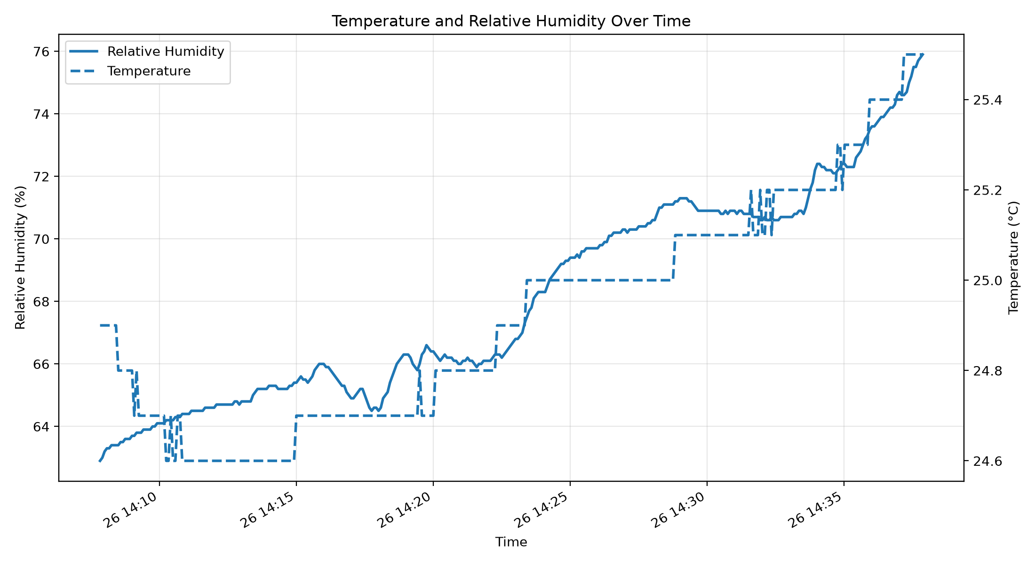

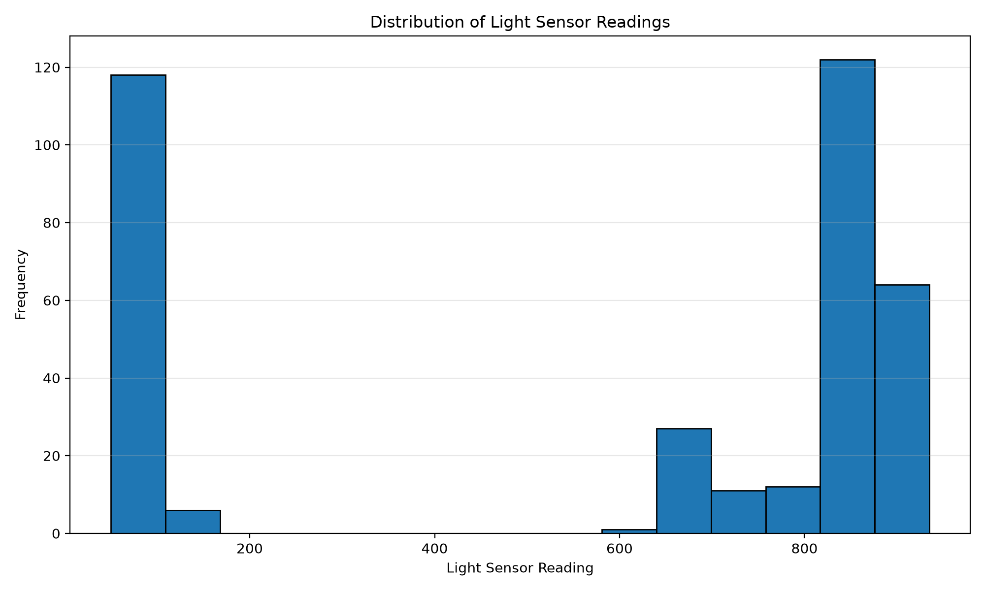
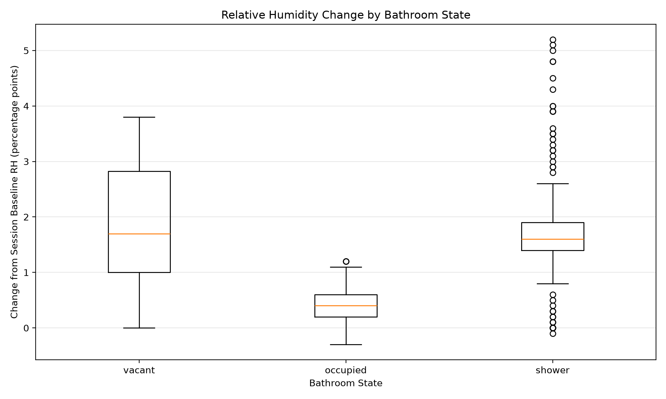

Statistical Testing and Hypothesis Validation

H1 – Combined Sensor Classification
H1 predicted that the combination of PIR, relative humidity, temperature and light would achieve better classification performance than any individual sensor.
This hypothesis was not supported by the collected dataset. The light sensor produced the highest individual classification accuracy at 63.5%, followed by PIR at 47.0%. Temperature alone achieved 4.4%, while humidity alone achieved 0%. Unexpectedly, the decision tree using all four sensors also produced an accuracy of 0%.

Sensor Configuration | Accuracy
Light Only | 63.5%
PIR Only | 47.0%
Temperature Only | 4.4%
Humidity Only | 0.0%
All Sensors | 0.0%

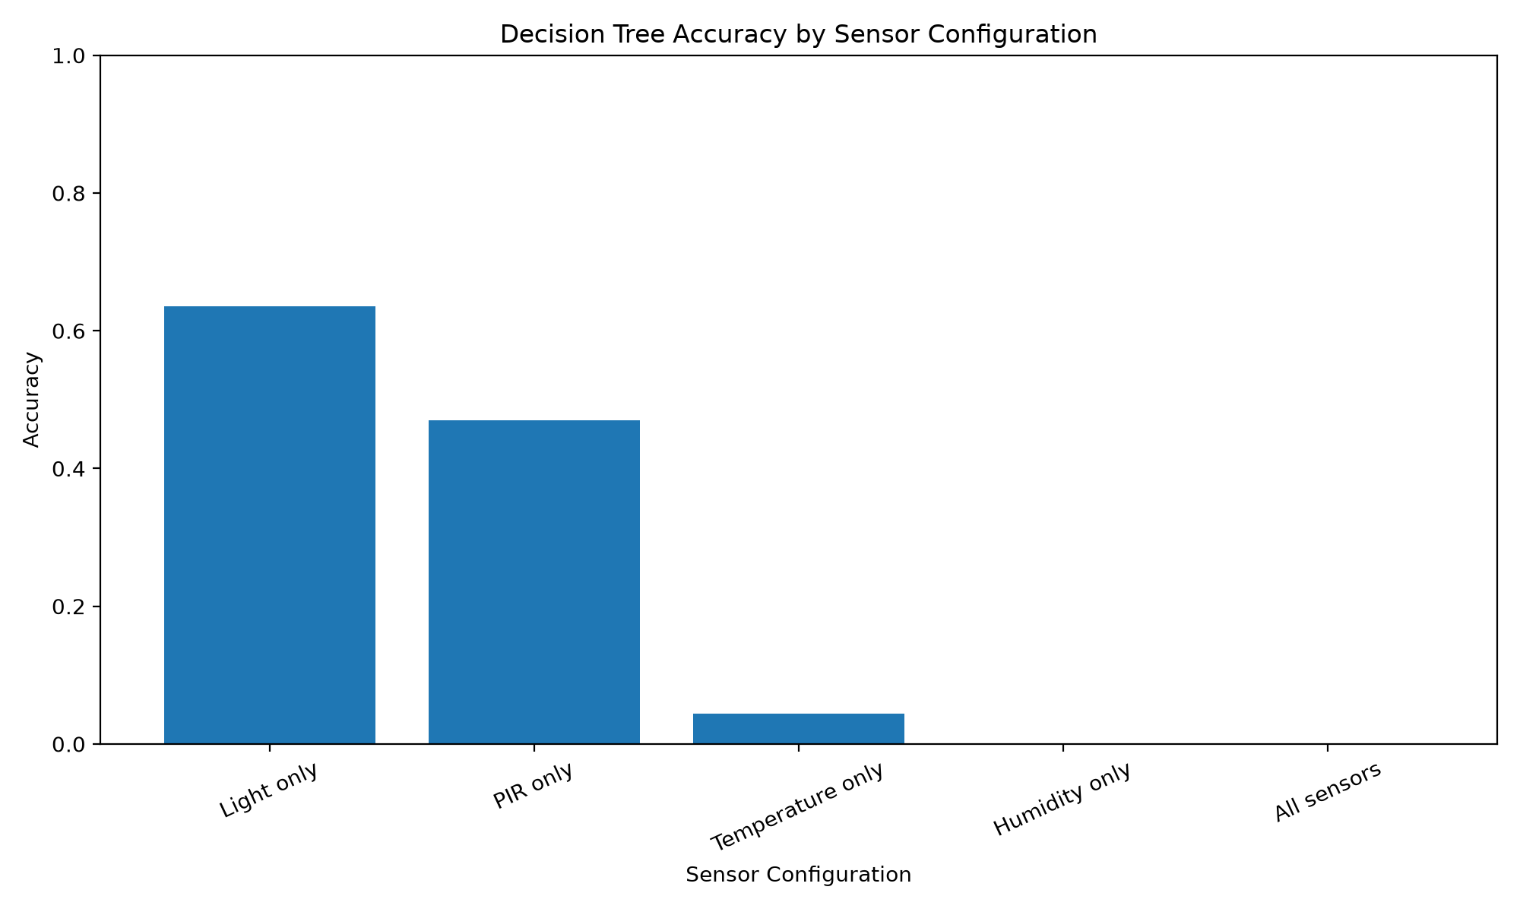
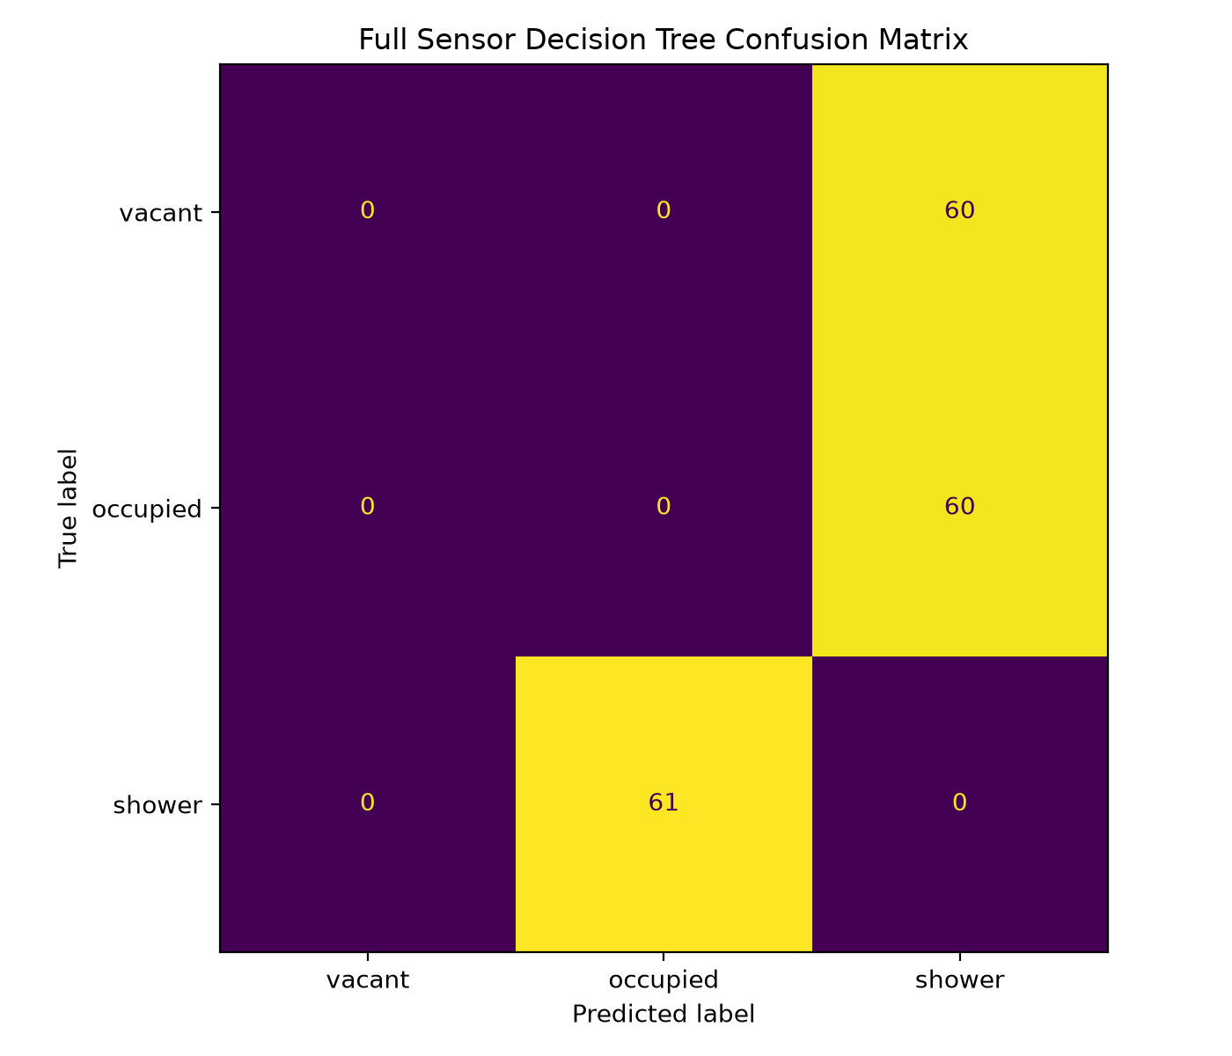
A likely explanation is that environmental conditions changed substantially between sessions. The session-based split trained the model using S03, S04 and S05 and tested it using S01, S02 and S06. For example, S04 was vacant immediately after a shower and began at a much higher relative humidity than the earlier vacant session. This means humidity and temperature could represent the order of the experiment rather than the actual room state. The result demonstrates why additional independent sessions across different environmental conditions would be required before evaluating the reliability of the classifier.

H2 Relative Humidity During Shower Activity

H2 predicted that shower sessions would produce a greater increase and rate of change in relative humidity than occupied sessions without shower activity.
The results were directionally consistent with H2. Shower sessions produced an average peak relative-humidity increase of 3.60 percentage points, compared with 1.00 percentage point during ordinary occupied sessions. The average humidity slope was approximately 0.595 percentage points per minute during shower sessions, compared with -0.016 percentage points per minute during occupied sessions.
However, Welch's t-tests produced p = 0.3479 for humidity increase and p = 0.3569 for humidity rate of change. Therefore, the differences were not statistically significant at the conventional p < 0.05 level. This is likely influenced by the very small sample of only two independent shower and two occupied sessions.
An important pattern was also observed between the two shower sessions. The shower conducted with ventilation operating increased from a baseline of 64.6% to a peak of 66.6%, an increase of 2.0 percentage points. The shower without ventilation increased from 70.7% to 75.9%, an increase of 5.2 percentage points. This suggests ventilation may have materially affected the humidity response.

H3 Reduced Sensor Array
H3 investigated whether a reduced sensor array could achieve performance comparable to the complete sensor array.
The best reduced configuration was PIR + light, which achieved 63.5% accuracy. In comparison, the complete four-sensor configuration achieved 0% on the held-out sessions. These results suggest that adding environmental variables did not improve classification in this particular experiment and instead reduced generalisation.
However, the result should not be treated as proof that PIR and light are superior to the complete sensor array. The experiment contained only six independent sessions, and the meaning of "comparable" was not defined using a formal equivalence threshold. Therefore, H3 cannot be conclusively confirmed from this dataset. The results instead provide evidence that a simpler sensor combination warrants further investigation.

Interpretation of Data

The collected data shows clear differences between the bathroom states. Relative humidity had a mean of 68.07% and ranged from 62.9% to 75.9%, while temperature remained relatively stable between 24.6°C and 25.5°C. This suggests that humidity was more responsive to bathroom activity than temperature. The time-series graph supports this, showing humidity increasing more strongly during and after shower activity.
Temperature and relative humidity had a strong positive correlation of approximately r = 0.938. However, this should not be interpreted as one directly causing the other, as both changed throughout the experiment and were influenced by the sequence of bathroom states.
The light sensor showed two clearly separated groups of readings, suggesting it was useful for distinguishing different lighting conditions. PIR and light also showed a moderate positive correlation of approximately r = 0.507, indicating that detected movement often occurred alongside higher light readings.
Humidity change also differed between states. Shower sessions produced an average peak increase of approximately 3.6 percentage points compared with approximately 1.0 percentage point during occupied sessions. This supports the expected direction of H2. However, the statistical tests were not significant, with p-values of approximately 0.348 and 0.357, meaning the hypothesis cannot be considered statistically supported from this small dataset.
The vacant-state humidity results also show an important limitation. The second vacant session occurred after a shower, meaning humidity remained elevated even though the bathroom was empty. This demonstrates that humidity alone cannot reliably indicate current occupancy and that previous bathroom activity can influence later readings. This environmental carry-over was also identified during protocol execution.
Overall, the results suggest that PIR and light provide more immediate indicators of occupancy, while humidity is more useful for identifying changes associated with shower activity. A combination of sensor measurements and temporal features is therefore more appropriate than relying on a single reading.

Limitations
The main limitation of the experiment was the small number of independent bathroom-use sessions. Although 361 sensor observations were collected, these measurements originated from only six sessions and consecutive sensor readings within the same session were highly related.
Environmental carry-over was another limitation. Humidity generated during shower activity remained elevated after the shower had ended, particularly during the following vacant session. Ventilation also appeared to influence the size of the humidity response.
The PIR sensor detects movement rather than occupancy itself and may fail to detect an occupant who remains stationary. Light measurements were also strongly influenced by whether the bathroom lighting was switched on, meaning they may perform differently under daylight or alternative lighting conditions.
Finally, the experiment was conducted over only approximately 30 minutes in a single bathroom. The resulting classifier therefore cannot be assumed to generalise to other times, users, bathrooms or environmental conditions.

Implications and Recommendations
This experiment demonstrated that low-cost, non-invasive sensors can capture meaningful differences between bathroom-use conditions, but the results also show that distinguishing the three states is more complex than identifying a single sensor threshold.
Future data collection should include substantially more independent vacant, occupied and shower sessions collected across several days. Training and testing should continue to use complete sessions rather than individual sensor readings. Ventilation state should also be controlled or explicitly incorporated into future models.
Further work could investigate additional temporal features and compare classifiers using PIR and light with models using environmental measurements. A CO₂ sensor could also be considered if the existing sensor array continues to have difficulty detecting stationary occupants.
Overall, the experiment provides preliminary evidence that light and PIR measurements are useful for occupancy classification and that shower activity produces a larger humidity response than ordinary occupancy. However, the limited dataset and changing environmental conditions prevented the full sensor classifier from generalising successfully. A larger session-based dataset would be required before determining whether the proposed system can reliably distinguish vacant, occupied and shower states.

Video Demonstration Link

